**ExperimentNo.1.5**

**Student Name:** Gaurav Kumar **UID:** 22MCC20177

**Branch:** MCA**–**CCD **Section/Group:** MCD-1/A

**Semester:** III **Date of Performance: 7**th Oct 23

**Subject Name:** DevOps Process Automation Lab **Subject Code:** 22CAP-745

1. **Aim/Overview of the practical:**
2. Create a Jenkins Freestyle Project which consists of Maven Build jobs.

**Note:** Trigger the builds of all the Maven 9 Goals.

1. **Steps for practical: (a)**
2. A screenshot of a computer program

   Description automatically generatedTo create a Jenkins Freestyle Project that consists of Maven Build jobs. First create a **Maven Project** with the help of any IDE.
3. Write main function code inside “**App.java”**.
4. Create a GitHub repository and push your code onto the GitHub.
5. After pushing your project on GitHub open Jenkins.
6. On Jenkins Dashboard click on **“+”** icon to create new **Freestyle Project**.
7. A new Window will appear give name to your Project and select Freestyle Project option and click **OK**.
8. 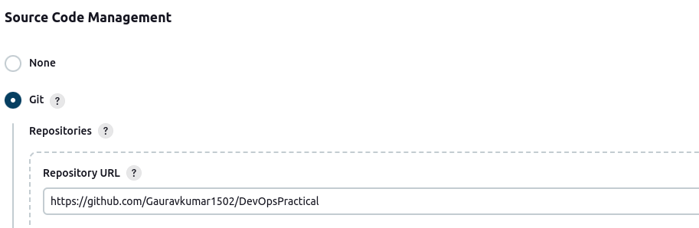A new Window will appear to add description and Git Repository URL and specify the branch name you want to build.
9. 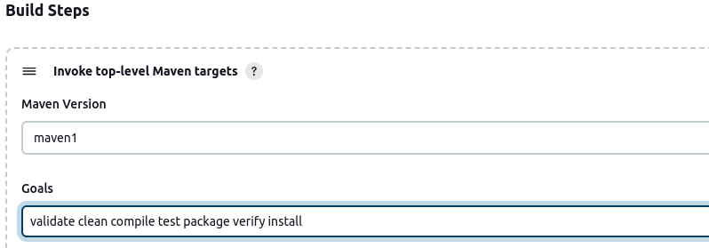After that in the **Build Steps** section select **Invoke top-level Maven targets** option and from the drop-down select maven version configuration and inside Goals field enter maven goals separated by space.
10. After setting up configuration click on **save** and **Build** **Now.**
11. 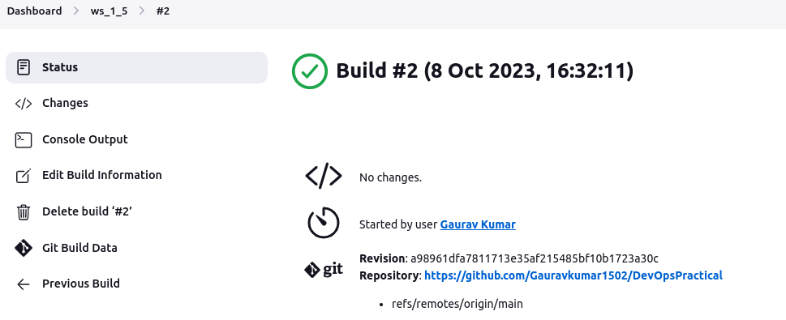You can see the result of your build by clicking on build number under Build history. Here you could see if the build succeeded or failed and can also see the output log.